

Topic test 1
Name: __________________________________

Chapter 3: Arithmetic and geometric sequences

• Time allowed: 45 minutes
• CAS calculators may be used.
• Part A: 5 multiple-choice questions (5 marks)
• Part B: 9 short-answer questions (28 marks)
• Part C: 5 analysis questions (18 marks)
Part A
Multiple-choice questions
5 multiple-choice questions
1 mark each: 5 marks
Circle the correct answer.
1 At the beginning of a particular day in winter in New York the temperature was 2°C at 8 a.m. It became steadily colder during the day, decreasing 0.3°C every quarter of an hour. The temperatures over a period of 3 hours are shown below.
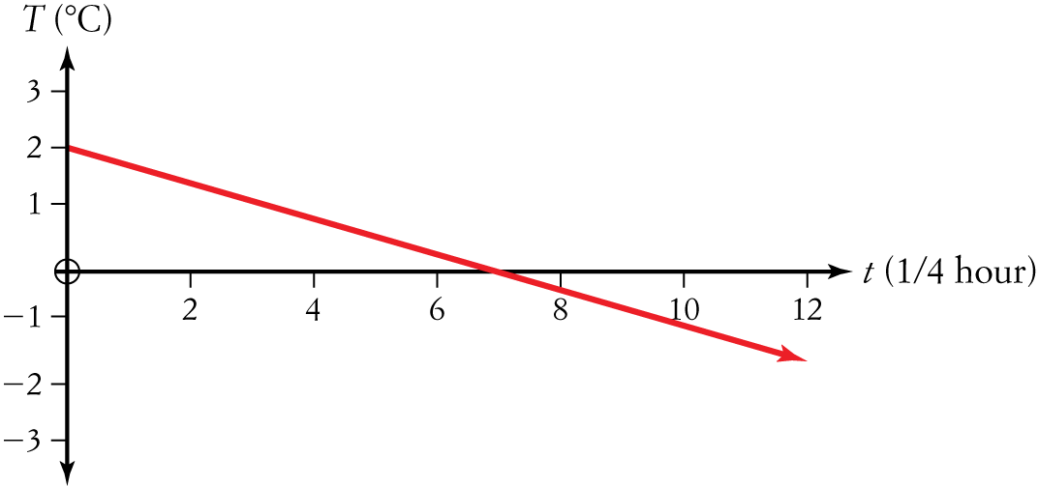
After how many hours, to the nearest hour, is the temperature 0°C?
A 2
B 4
C 5
D 7
E 1
[1 mark]
2 The first four terms of a sequence are −2, −8, −14, −20. The eighth term of the sequence is:
A −2
B −26
C −44
D −50
E −184

[1 mark]
3 The first four terms of a sequence are −2, −8, −14, −20. The sum to the eighth term of the sequence is:
A −2
B −26
C −44
D −50
E −184

[1 mark]
4 The common difference d = tn − tn−1 for the sequence −2, −8, −14, −20 is:
A −2
B 2
C 6
D −6
E −44

[1 mark]

5 The common ratio 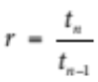 for the sequence , −4, 32, −256, … is:
A 9
B −9
C 8
D −8
E

[1 mark]
Part B
Short-answer questions
9 short-answer questions
28 marks
Show your working where appropriate.
1 Find the arithmetic sequence if the first term in the sequence is 5 and the 10th term is −10.

[3 marks]
2 If the first six terms of a sequence are −2, −5, −8, −11, −14, −17, state the sum of the sequence to
10 terms.

[3 marks]

3 Find the sum of the arithmetic sequence 7, 14, 21, 35, …, 112.

[4 marks]
4 Calculate the sum of all the multiples of 5 between 1 and 51.

[4 marks]
5 If x, x − 1, and x + 3 are the first three terms of a geometric sequence, calculate the value of x.

[2 marks]
6 Find the first four terms of the sequence described by the recursion:
a1 = 5 and an = −2an −1+ 2.

[2 marks]
7 If the first six terms of a sequence are 2, 6, 18, 243, 729, 2187, state the value of the 12th term of the sequence.

[3 marks]
8 Find the common ratio r = 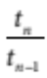 for the sequence 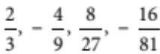, …

[2 marks]
9 Find the geometric sequence if the fourth term in that sequence is −2 and the 10th term is −32.

[5 marks]
Part C
Analysis questions
5 analysis questions
18 marks
Show your working where appropriate.
1 The price of shares in a particular company is falling by an average of 2% each day.
a What percentage of their value are the shares worth after 2 days?

b How many days will it take for the shares to halve in value?

c Find the value of the shares after 4 weeks if they were originally worth $9.55.

[4 marks]
2 A geometric series has a limiting sum of 40 and its first term is 5. Find the common ratio and hence the geometric sequence.

[3 marks]
3 A timber fence is to be built on sloping land, with the shortest piece of timber 1.2 m and the longest piece 1.8 m. There are 61 pieces of timber in the fence.
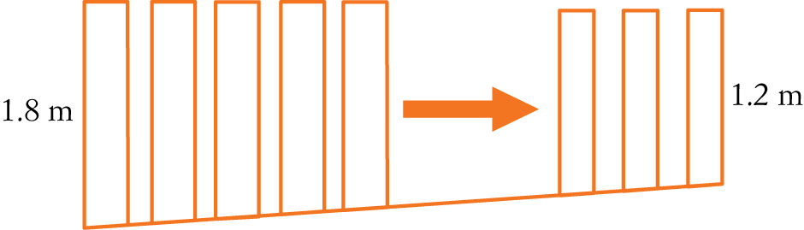
a What is the difference in height between each piece of timber?

b What length of timber is needed for the fence altogether?

[3 marks]
4 A tree 3 m high grows another 2 m after 5 years, then another 1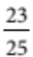 m after 5 more years and so on, each year growing more than the previous year’s growth. Find the eventual height of the tree.

[3 marks]

5 A ball is dropped from a height of 2 metres and bounces up to of its original height. It continues bouncing, rising of its height on each bounce until it eventually reaches the ground.
a What is the total distance through which it travels?

b Will the ball ever stop bouncing?

[5 marks]
[Total marks: 51]
Answers
Part A – Multiple-choice questions [1 mark each]
1 From the graph, T = 0 when t = 7.
No. of hours = × 7 = 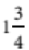 < 2.
 A
2 a = −2
d = −8 − (−2) = −6
tn = −2 − 6(n − 1)
t10 = −2 − 6(8 − 1)
= −2 − 6 × 7
= −44
 C
3 a = 2
d = −6
Use the formula:
Sn = [2a + (n − 1)d]
S8 = [−4 + 7 × −6]
= 4(−4 − 42)
= −184
 E
4 d = tn − tn−1
= −8 − (−2)
= −14 − (−8)
= −20 − (−14)
= −6
 D
5 r =
= 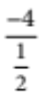 = 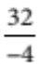 = 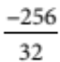
= −8
 D
Part B – Short-answer questions
1 t1 = a = 5 and t10 = −10
Use a = 5 and tn = a + (n − 1)d to solve for d.
5 + (10 − 1)d = −10 [1 mark]
9d = −15
d = 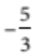 [1 mark]
The arithmetic sequence is 5, 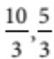, 0, … [1 mark]
2 For the sequence −2, −5, −8, −11, −14, −17, a = −2, d = −3. [2 marks]
Use Sn = [2a + (n − 1)d] to find S10.
S10 = 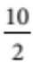[2(−2) + (10 − 1)(−3)]
 S10 = −155 [1 mark]
3 For the arithmetic sequence 7, 14, 21, 35, …, 112, a = 7, d = 7, l = 112. [2 marks]
Use Sn = (a + l) where l = tn = a + (n − 1)d.
Solve for n, l = tn = 112 = 7 + (n − 1)7 gives n = 16. [1 mark]
 S16 = 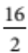 (7 + 112) [1 mark]
 S16 = 952
4 Arithmetic sequence is 5, 10, 15, 20, …, 50, where a = 5, d = 5, l = 50. [2 marks]
We need to choose 50 because that is the last multiple of 5 before 51.
Use Sn = (a + l) where l = tn = a + (n − 1)d.
Solve for n, l = tn = 50 = 5 + (n − 1)5 gives n = 10. [1 mark]
 S10 = (5 + 50) [1 mark]
 S10 = 275
The other sum formula could also be used, using n = 10.
5 Using r = 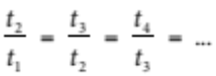 gives r = 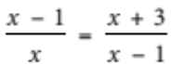. [1 mark]
x(x + 3) = (x − 1)(x − 1)
x2 + 3x = x2 − 2x + 1
0 = −5x + 1
5x = 1
x = [1 mark]
6 Sequence is 5, −8, 18, −34. [2 marks]
7 Sequence 2, 6, 18, 243, 729, 2187, where a = 2, r = 3. [2 marks]
Using tn = arn−1 to find t12
t12 = 2(3)12⁻1 [1 mark]
 t12 = 354 294
8 Using r = 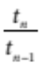 to find r = 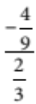 [1 mark]
Gives r = 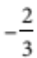. [1 mark]
9 t4 = −2 and t10 = −32 [1 mark]
tn = arn⁻1 to solve simultaneously for a and r.
ar4⁻1 = −2 and ar10⁻1 = −32 [1 mark]
gives a = 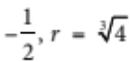 or a = 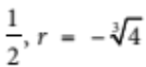 [2 marks]
The geometric sequence is 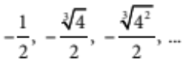 or 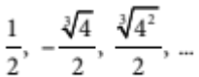 [1 mark]
Part C – Analysis questions
1 a Falling by 2% means the shares are worth 98% of their original price.
0.98 × 0.98 = 0.9604
= 96.04% [2 marks]
b 0.98n⁻1 = 0.5
Use solve on calculator = 35 days [1 mark]
c 9.55 × 0.9816 = $6.91 [1 mark]
2 Using 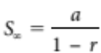 for a limiting sum of 40 where a = 5. [1 mark]
Solve 40 = 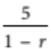
 r = [1 mark]
Sequence is 5, 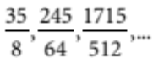 [1 mark]

3 a a = 1.2, l = 1.8, n = 61 [1 mark]
Using tn = a + (n − 1)d with l = t61 = 1.2 + (61 − 1)d = 1.8
Gives d = 0.01
 Difference in height between each piece of timber is 0.01 m. [1 mark]
b Using Sn = [2a + (n − 1)d] where a = 1.2, d = 0.01, n = 61
length of timber = 91.5 metres. [1 mark]
4 a = 3, r = [1 mark]
Use 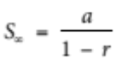 with a = 3, r = . [1 mark]
 Eventual height of tree = 15 metres. [1 mark]
5 a Use with a = , r = [2 marks]
Distance travelled is original 2 metres plus twice the height of each subsequent bounce.
Total distance travelled =
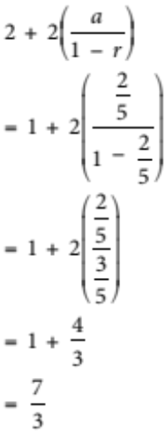
= 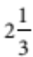 metres [2 marks]
b As this is a limiting sum, in theory, the ball will never stop bouncing.
[1 mark]

